PROJECT DESIGN PHASE
Proposed Solution
Automated Network Request Management in ServiceNow
Date | 14 September 2026
Team ID | —
Project Name | Automated Network Request Management in ServiceNow
Maximum Marks | 2 Marks

Proposed Solution
A ServiceNow-based automated network request management process that standardizes request submission, validation, approvals, fulfilment, tracking, and notifications.
S.No. | Parameter | Description
1 | Problem Statement (Problem to be solved) | Network service requests are often submitted through inconsistent channels, with incomplete information, manual approvals, repeated follow-up, and limited visibility of request status and fulfilment.
2 | Idea / Solution description | Build a ServiceNow-based Network Request solution using a Service Catalog item, structured variables and variable sets, validation, Catalog UI Policies, approval routing, fulfilment tasks, notifications, navigation flow, and status tracking.
3 | Novelty / Uniqueness | A standardized request experience combines requester information auto-population, conditional form fields, approval workflow, automated task routing, and end-to-end request visibility in one ServiceNow process.
4 | Social Impact / Customer Satisfaction | Users receive a clearer and more predictable request experience, while fulfilment teams receive complete and structured information and can process requests through a consistent workflow.
5 | Business Model (Revenue Model) | The solution is intended as an internal enterprise IT service-management capability. Value is generated through reduced manual effort, fewer incomplete requests, faster routing, and improved operational visibility rather than direct end-user revenue.
6 | Scalability of the Solution | The catalog can be extended with additional network request types, variables, approval rules, UI policies, fulfilment groups, integrations, and automated network-device actions as future enhancements.

Figure 1: Proposed solution flow for Network Request Management
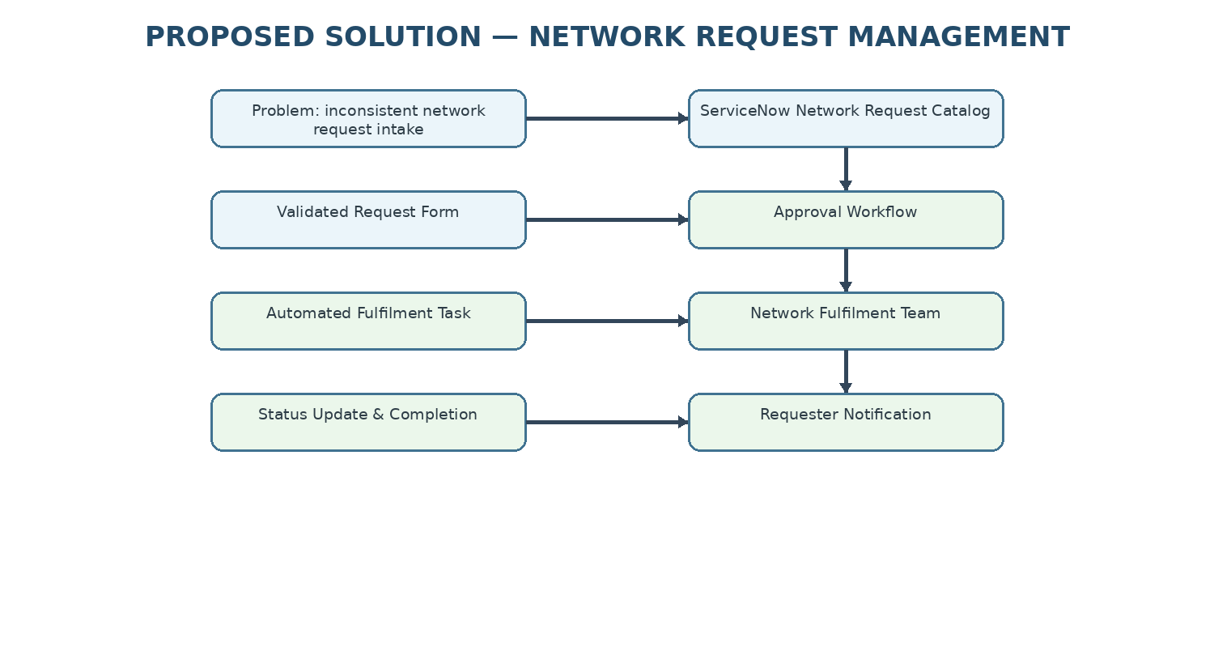
Phase 3 implementation covered
• Creation of the Network Request Service Catalog item.
• Configuration of catalog variables and a Requester Information variable set.
• Conditional field behaviour using Catalog UI Policy.
• Service Portal navigation and request submission flow.
• Request number generation, summary visibility, and user notifications.

